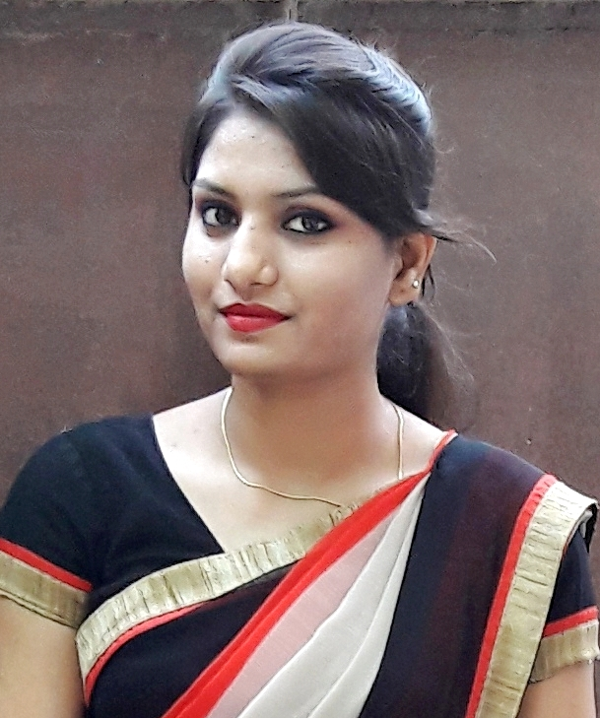
MONIKA SINGH
MBA, PGDM, BBA
Date of Birth: 27/03/1991
Mobile No: +91-7376848458
Home: 9415352772/9453002156
singhm91@gmail.com
N-4/ 35 A, 51-A
Viveknager colony, Sunderpur ,Post – BHU, Varanasi U.P.

- Currently working as Lecturer (BBA) in Dheerendra Mahila P.G. College, Varanasi.

Career Objective
Seeking a challenging position in a repudiated institution to utilize my skills and abilities in area of Teaching and Education that offers a professional growth while being resourceful, innovative and flexible.

Academic Qualifications

Examination Passed | Board /  University | Year of Passing | Division/  %age of Marks | Subjects / Specialization
MBA | Dr. A.P.J. Abdul Kalam Technical University, Uttar Pradesh, Lucknow | Pursuing
PGDM  (2 year Full time  Regular Post Graduate Diploma in Management  ,AICTE Approved,) | School Of Management Sciences,  Varanasi  Approved by AICTE, Ministry of HRD, Govt. of India, New Delhi | 2012 | 7.47  ( CGPA ) | HR
BBA  (Bachelors in Business Administration) | School Of Management Sciences,  Varanasi  (Affiliated to VBS Purvanchal University, Jaunpur) | 2010 | 71.0 % | HR
12th | UP Board | 2007 | 68.8 % | Commerce
10th | UP Board | 2005 | 71.0 % | All subjects

Work experience

- Currently working as Lecturer (BBA) in Dheerendra Mahila P.G. College, Varanasi from 1st July 2015 to present.
- Taken subjects like – Business Ethics, Industrial Law, Environment & Entrepreneurship, Organisational Behaviour, Sales management, Consumer Behaviour, E- Commerce, Business Communication, Fundamentals of management in Dhirendra Mahila P.G. College. Guided Survey reports of last semester students.
- Worked as HR & Admin Incharge in ASSETS INSTITUTE, Varanasi from 02nd May 2012 to 25th June 2015.
- Taken classes at CS and ICWA Foundation level in ASSETS INSTITUTE, Varanasi from 02nd July 2012 to 30th May 2015.
- Chapter Contributed in Edited Book (2016) – Human Resource Management, Chapter – “Global Human Recourse Management”, R.S. Publishing House Kabir Chaura ,Varanasi.
- Article Published in Journal (2016) in Social Sciences and Humanities, Topic – “Human Rights of People With Disabilities in India”, R.S. Publishing House Kabir Chaura, Varanasi.
- Article published in annual magazine (November 2015) of “Dheerendra Mahila P.G. College” on topic of – ‘Generation Gap & Nurturing as Parent’.

Extracurricular Achievements and Activities
- Actively participated in “Newsletter” (a bi-annual publication of SMS group of institutions).
- Paper Presented on the topic of “Management lessons from Bhagvagd Gita” in Ethics and Spirituality conference as well as in International Conference. (Organized by SMS, Varanasi).
- Paper Presented on the topic of “Fusion Marketing” in National Conference - “Innovation and Creativity in management” (organized at SMS, Varanasi).
- Certificate of participation in International conference on “Spiritual Paradigm for Surmounting Global Management Crisis”.
- Certificate of participation in Hero Moto Cops Idea presents Campus Konnect 2012 organized by Amar Ujala (2nd Runner Up).
- Certificate of 75 days Training program on “Entrepreneurship Development and Techno Managerial Aspects of Food and Fruit processing” conducted by National Institute for Entrepreneurship and Small Business Development (NIESBUD).
- Actively participated in sports, GDs, games & quizzes and cultural events.
- 1st runner up in dancing competition.
- Selected as Ms. Talent in graduation, Ms. Fresher in post graduation & Ms. Farewell in post-graduation.

Snapshot
- In depth knowledge of the fundamental of Management and Business administration and their practical usage.
- A post graduate in HUMAN RESOURSE with significant exposure.

- Successfully completed project report on :
- Research Report on the topic “Factors influencing Job Satisfaction of Employees”.
- Survey Report on “Consumer preferences towards Soft drinks in Varanasi”.
- Field survey project on “Factors affecting the buying decision of cars in the Varanasi city”.
- Survey report on “Organizational Climate Survey of Motherdairy Fruits & Vegetable Pvt. Ltd. (Milk Sales Division)” Noida from 2nd May to 2nd July 2011..
- Business Plan 0n “Little Angel –Day Care Centre”

Strengths
- Self motivated and ability to work independently towards a team goal, & produce the required result with in time bound.
- Positive and Creative in doing things.
- Excellent command over Paint, Excel, PowerPoint MS-Word & Internet.

Area of Interest
- People Management, Administration, Cultural Events, Education and related fields of Management.

Declaration

I hereby declare that all the details furnished above are true to the best of my knowledge, thanking you.

Date:
Place: Varanasi

